**Assignment 1**

**Experience Interactions!**

(Intro Design for Interaction - IXD-5106-0NC)

* In our day-to-day life there are lots of websites/apps that we interact with, but we don’t pay much attention in context with their design, purpose and many other things.
* Here is list of five day-to-day apps/websites which I found useful in my routine lifestyle:
  + **Learn.humber.ca (Website)**
  + **Google maps (Application)**
  + **Office.com (Website)**
  + **Microsoft** **teams (Application) / teams.microsoft.com (Website)**
  + [**www.google.com**](http://www.google.com) **(Website)**
* Let's talk about each of them what was the context I used that website/application, what was the mode of communication, what all actions I took, my thoughts on that or what I felt.

**Learn.humber.ca (Website)**

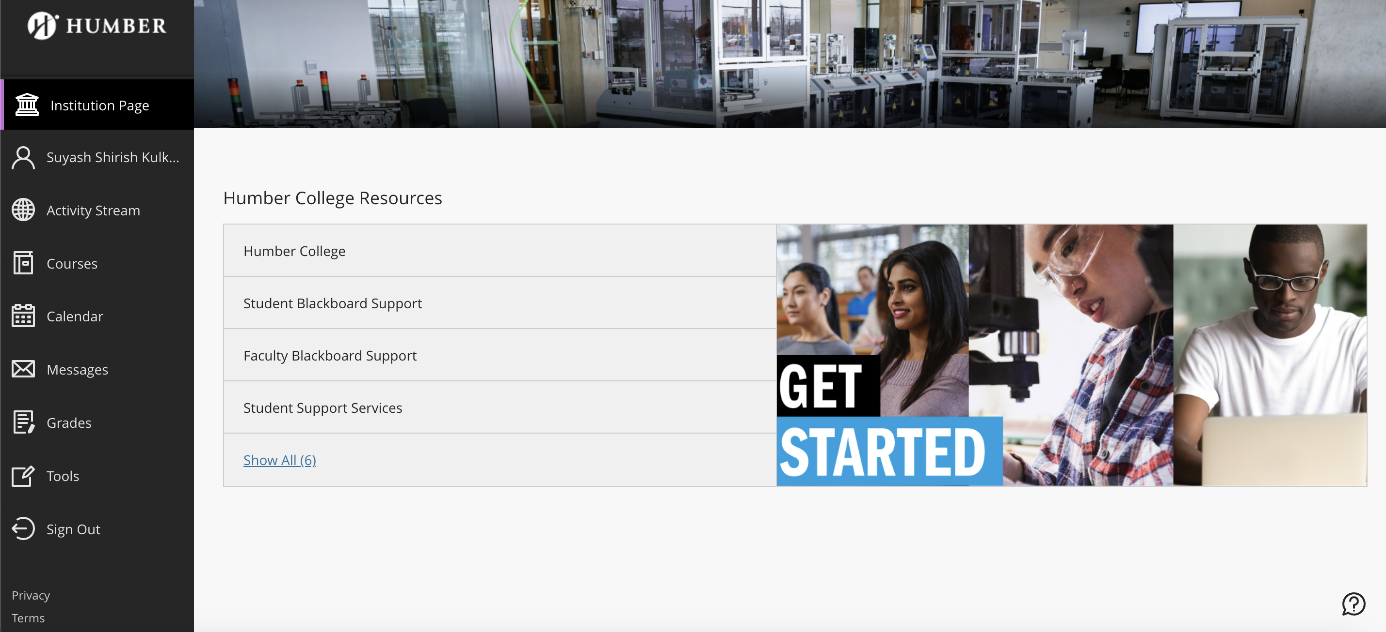

* **The context (when, where, and why the interaction occurred):** As I got enrolled in Humber college these website helps me to track everything related to my course or related to my subjects. The reason behind the interaction was I need to check where my first lecture is schedule at what time and in which room.
* **The device or product involved: I used my laptop to access the college learn.humber.ca site with my students' credentials.**
* **The actions taken while interaction:** 
  + Opened browser in my laptop and navigated to the learn.humber.ca site.
  + Got logged in using my student's credentials.
  + Now I can access the site and navigate through courses and Callender and different functionalities.
* **Any thought or emotion felt during interaction:** 
  + I really felt convenient as I can easily manage everything at one place including my study materials, assignments, grades, interaction with professors, asking doubts, receiving feedback everything just on one login.
  + At some point I felt frustrated as I was facing some internet issue, and I was not able to access the study materials which I needed urgently. So, from then I stated downloading them as and when required for my ease.
  + As it is based on student's login so another student can't see mine and vice versa also helps me to stay away from embarrassment due to some mistakes identified by professor it just stays in between the professor and the student which every good thing.

**Google Maps (Application)**

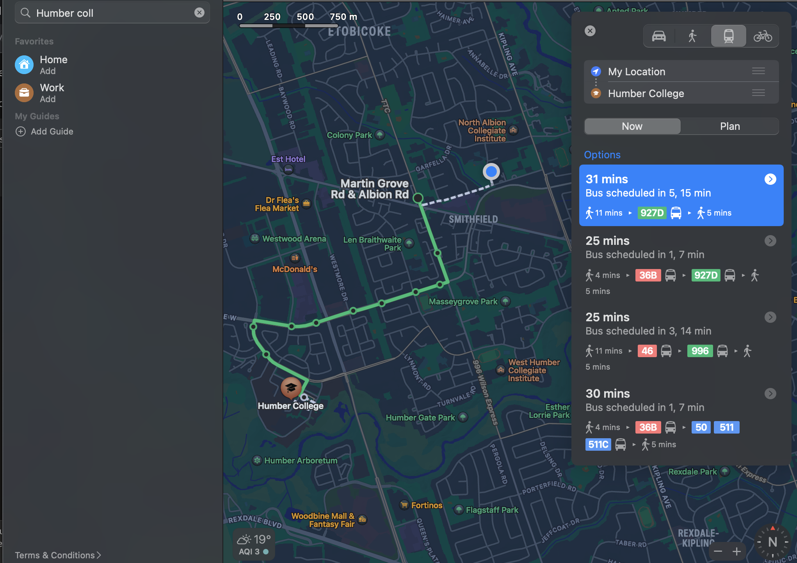

* **The context (when, where, and why the interaction occurred): It is about the last Sunday when I wanted to visit to my friend's place as he needed me. I had his address but was not known the area where he lives. The area was new for me and was not aware how can I reach there so I decided to use the google maps application to guide me to my destination.**
* **The device or product involved: I used my smart phone with the google maps application installed in it. We need to also enable our location to use the application.**
* **The actions taken while interaction:** 
  + Open the application in smart phone.
  + Search for the destination you are looking for in my case it was my friend's house.
  + Google maps provided the directions and the transportation schedule with total time.
  + Selected the preferable mode of transportation and schedule was up there followed by the path I need to walk with proper directions.
* **Any thought or emotion felt during interaction:** 
  + It is really a great application makes me feel relieved as I have google maps so the fear of losing in an unknow city or area is eliminated.
  + The other reason that makes me feel relaxed is we know the estimated time that’s gone take to reach my destination.
  + One more thing which helped me is that I missed my bus on the scheduled time, and I sat on the wrong bus, and it suggested my the correct way and guided me how to change the bus and go to the correct direction.

**Office.com (Website)**

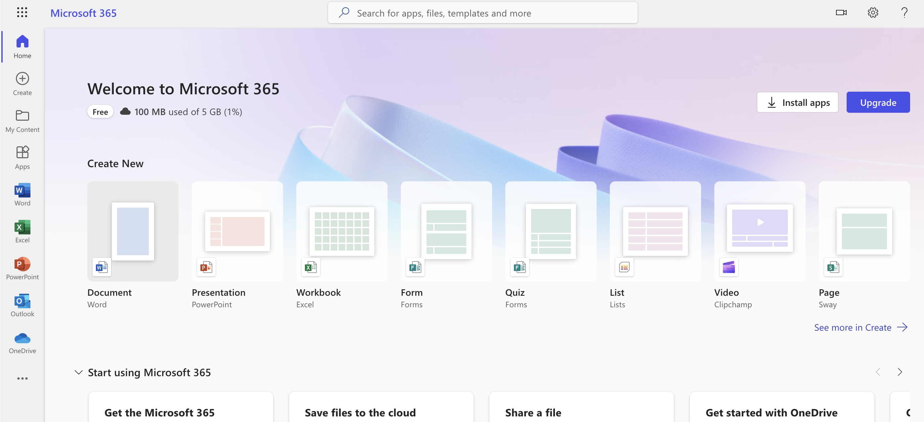

* **The context (when, where, and why the interaction occurred):** The interaction occurred on every first day of college as we were doing lap assignments and need to create one document file. Instead of purchasing I just got logged in my Microsoft account and accessed word from my laptop and created the document to submit.
* **The device or product involved: I** used my laptop to be logged in into the office.com website.
* **The actions taken while interaction:** 
  + Opened browser in my laptop and navigated to office.com website.
  + Got logged in with my Microsoft account credentials.
  + After login I landed on the home page and on the left panel, we have all the Microsoft necessary tools.
  + Opened word from there and started creating the document and it got saved on OneDrive so I can even access it from my phone or anyother laptop without sharing that document.
* **Any thought or emotion felt during interaction:**
  + I felt convenient as I am using mac, I need to purchase the Microsoft office 365 whole collection to access the word to create the document.
  + But I can use the website free of cost and create documents which will be stored on OneDrive so in some cases even if I forgot my laptop I can just logged in and access my document from anywhere.
  + **No fear of losing the data as it is all managed in centralized data collection called OneDrive.**
  + **There is also a security that my work is being saved continuously as I am using the office.com it has a built-in feature to auto save after every single change is made.**

**Microsoft teams (Application) / teams.microsoft.com (Website)**

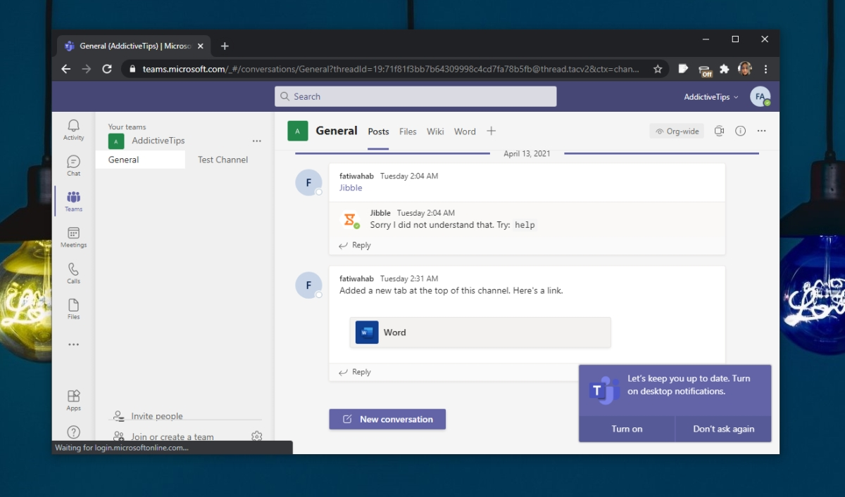

* **The context (when, where, and why the interaction occurred):** The interaction happens on weekly bases as I have an online lecture to attend for one of subjects.
* **The device or product involved:** I used my laptop for interaction with Microsoft teams application installed in it.
* **The actions taken while interaction:**
  + Opened Microsoft teams application my laptop.
  + Created a new account with my name and credentials.
  + Opened browser and navigated to learn.humber.ca site and in the subject, I found the teams link to join the online lecture.
  + After opening the link, it navigated me to my application and one page was opened from there we can set background image, or we can turn on the camera or mic.
  + Then I joined the class.
* **Any thought or emotion felt during interaction:**
  + Talking in front of 25 to 30 students makes it difficult for me so it was a good chance to speak with new students instead of feeling embarrassments to talk. This made me a bit more comfortable to attend the lecture.
  + Another moment of joy was we were recording the whole session, and I can watch it any time to clear my doubts.

**Google.com (Website)**

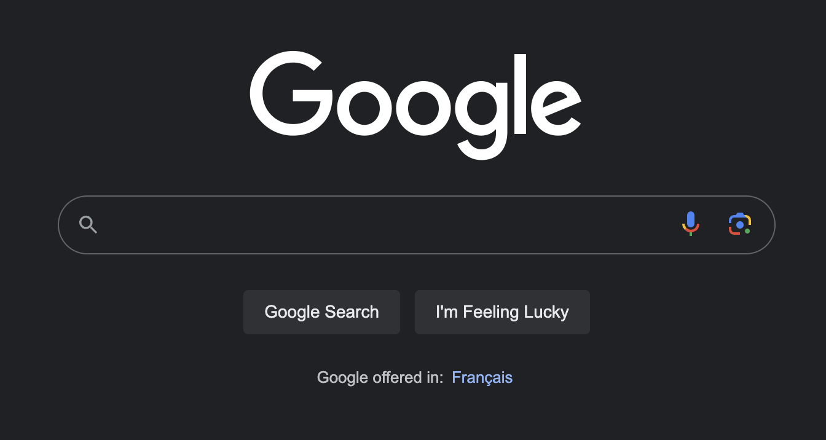

* **The context (when, where, and why the interaction occurred):** The interaction occurred when I wanted to do some research on one of the topics which was new to new.
* **The device or product involved:** I used my laptop for the interaction as google.com is the home page for my browser.
* **The actions taken while interaction:** 
  + Opened my browser and navigated to google.com site.
  + Searched my topic in the search box and I found lots of links regarding the same topics.
  + Did some research through all the links and collected all the necessary information found from all those links.
  + Also used the bookmark feature for the sites that had a lot of content and was not able to copy all of it at once.
  + Also used the image search functionality provided by google to search images for my research topics.
* **Any thought or emotion felt during interaction:**
  + I felt every excited for my research on my topic and I found literally a lot of things with the topic context and was happy to document them all in a proper way for my presentation.
  + The efficiency was good and accurate data was gathered from right sources. It saved a lot of time for me in my research presentation.
  + Sometimes I felt frustrated due to the add pop ups which were randomly coming while searching and they were a bit time consuming.

**In-Depth Analysis**

**Google Maps (Application)**

* **Primary Goals:**
  + **Navigation**: It helps users to find their location from one point to another point based on their current location. It also provides information on real time traffic with alternatives routes. It also provides information regarding mode of transport to your destination.
  + **Location Search**: Users can easily search locations for restaurants, hotels, grocery stores, addresses, and many more things.
  + **Facilities around the location**: Maps also provides information about local stores, petrol pumps, restrooms etc surrounding your current locations with their proper location, phone number, opening and closing hours of the store and many more.
  + **Public transportation**: Maps also includes all the information about public transportations with their schedule, cost of travel, estimated time to reach to your destination. Their main goal is to assist users to plan their journey using public transport with ease.
  + **Offline maps**: It also provides facility to download maps to access them without internet. This helps when you are travelling to the remote places with low network frequency.
  + **Real-time traffic update**: Maps provides real time traffic information with traffic jams, road under construction and based on this provides alternative routes to reach to your destination.
  + **Location Sharing**: It provides facility to share your real-time location with your friends and family members. This enhances the security by knowing your known members location and whereabouts.
* **Interactions with the application:**
  + **Stage 1:** Location Search
    - Open google maps application in your device.
    - Enter your destination in the search bar located on the top of the screen. It could be address, bus stop, landmark, mall, restrooms etc.
    - Once you have search based on the results shown review all the results and find best possible option to reach to your destination.
  + **Stage 2**: Route Selection
    - After searching your destination, it shows all the possible routes to reach to your destination including the fasted and the slowest route. It shows routes based on driving, walking, public transport, cycling.
    - Select the best possible route according to your requirement including cost and estimated time to reach your destination. Once you select the route it highlights the path that you have selected.
    - It shows the estimated time to reach to your destination based on your mode of transport.
  + **Stage 3**: Directions
    - Click on the start button located below of the screen to start the navigation from your location to your destination based on the selected path.
    - Follow the directions as mentioned in the maps with turns and curves as well. It also provides the voice guidance if needed.
    - Also check traffic on your selected route and it provides an alternative route to select in-case you have more traffic in your selected route.
  + **Stage 4**: Nearby Locations
    - It provides information about the nearby location with different icons used on the map or your route.
    - You can add stops if you need to visit that location in between your destination.
    - It also provides reviews, ratings and cost for the stops like restrooms, restaurants, food stores, grocery stores and many more.
  + **Stage 5**: Destination
    - Follow the directions until to reach your destination.
    - Once you reach your destination click on the done button to end the navigation session in the maps.
    - You can save your current location or even share it with your friends, family members and others.
* **User Interface, Feedback mechanism and User Inputs**
  + **User Interface**:
    - It has a simple, user friendly Ui and easy to understand for naïve person.
    - The main centre area is covered by map to display the location by geographical means.
    - Then on the upper side we have search bar to search the location. Once you click on the search bar it shows my location (Your current location) and other is your destination field where you need to search your destination.
    - Then we have suggestion panel were based on your searched characters results are shown and you can directly select the relevant result instead of typing everything.
    - Then we have different buttons which are using to indicate cycle, bus, train, walking, speaker if you want to listen the directions.
  + **Feedback Mechanism:**
    - Users can add their reviews regarding their journey using google maps and they improve their app based on the reviews and feedback of the users.
    - You can also report traffic jams which indirectly helps other users to improve their route selection.
    - You can also report a problem that you have faced in the application if you have faced any.
    - You can easily add or update location pictures if there aren't any and add suggestions regarding application.
  + **User Inputs**:
    - Users can search location for the destination where they want to visit.
    - Report traffic jams if they face any during their journey.
    - They can also contribute by providing reviews, photos and additional information regarding hotels, grocery stores and many more places.
    - During journey user can add stops in between their destination like stopping at any nearby petrol pump etc.
* **Usability and User experience (UX)**
  + **Usability:**
    - The application is designed to increase your efficiency by providing alternative routes or shortest routes.
    - It is very easy to learn, and anyone can easily learn it. It does not require any big manual or major steps to learn the application.
    - It also handles spelling mistake error done by the user by providing relative suggestion to provide the accurate location.
    - It also maintains the same design on application as well as on the website, so we don’t need to invest extra time to learn the web version in-case we need to use it someday.
  + **User Experience (UX):**
    - It provides a clear view to the maps with clear icons visible in the app and easily understandable by seeing the icon what is meant for.
    - We can easily customize the application by saving our own location as **Home** and our favourite places, so we don’t need to search it again and again.
    - It covers a diverse category of people by providing different facilities for the one who are disabled.
    - Offline mode is one of the best features if you are visiting to a remote place, it helps you find everything even if you face problem with connectivity.
* **Reflection on how design choices influenced my thoughts and emotions**

The design of the application influences my thoughts and emotion based on each interaction I had with the application. I use it on regular bases to travel in the town. After using so many times I have found that the application is created by user centric approach which enhances the overall experience of the application.

One of the main things which I felt is it is reliable, efficient, and accurate with the routes it provides. They have used the common and simple icons to identify the things in the application which makes it more familiar to the user. I rely on it for the real-time traffic tracking feature to save time by taking the alternative routes to reach to my destination. It also provides the fastest route possible with the estimated time based on real-time traffic and it is also accurate, and we can make the right decisions on right time.

It also provides to make a personalised list including your home location, office location, favourite restaurants and many more to avoid searching the same places again and again. It also has error handling feature in-case you miss-spelled something it provides accurate suggestions so you can select it based on the suggestions which indirectly saves time and increases efficiency.

Overall, the design choices are very simple and easily understandable by the naïve person. Its main power is it is user-centric which shapes your digital experience in a much better way. It has made everyone in depended even if you are in a new country, city or town.

